|  |
| --- |
| GOURAB DAS |

***To work in a competitive and challenging environment where I can serve my organization and establish a distinguished career for myself with the proficiencies.***

***Professional Summary***

* Expertise in developing applications using ***PowerApps***, canvas, Forms, SharePoint online.
* Trained in ***DevOps***, Creating and managing a ***Docker*** deployment pipeline for custom application images in the cloud using ***Jenkins***. Deploying and monitoring scalable infrastructure on ***Amazon web services (AWS)*** & configuration management.
* Trained as a ***full-stack Java Developer.***

Skills Profile

Technical

|  |  |
| --- | --- |
| **Operating System** | Windows 10 |
| **Environment** | Apache Server |
| **Database** | MySQL, PostgreSQL |
| **Internet Tools** | HTML, Java Beans |
| **Languages** | C programming, JAVA |
| **Other** | JDBC, JPA Hibernate, Spring Boot |

Functional

|  |  |
| --- | --- |
| **Management and Leadership Skills** | Ability to develop and lead a team for specific work, Project Management, Strategic/ Tactical Planning, Business Analysis, and Development. Giving and receiving feedback, being a good listener, and a mentor. |
| **Training & Development** | Core JAVA, Spring, JPA Hibernate, Jenkins, Git, JEE Cloud, AWS, Kubernetes, Dockers, Microsoft Power Platform etc. |

Professional Experience

|  |  |
| --- | --- |
| **Blogging site Application** | 09/2021 |
| ***MADE Service, Controller and Entity Layer*** |  |

Project based on the development of a SpringBoot Application to perform all the CRUD operations using PostgreSQL as database and Swagger as UI configuration , Creating image using Docker and deployment of services using Kubernates

• SpringBoot, PostgreSQL., Postman

• Swagger, Jenkins, git

• Docker , Kubernates

***Environment:*** *Hardware:HP Laptop,Operatiog System: Window 10, Software: Eclipse IDE 2020, Language: JAVA(Spring))*

* ***1. Projects on Power Platform.***
* ***Canvas App:***
* *Design & Development of Canvas Applications, which has rich UI navigation. Profound knowledge in Gallery, Form, Components, Formulas concepts. Created a Canvas App with authentication for display and update employee data from a data source(SharePoint list).*
* *Created a Canvas App for Timesheet entry for employees and resume upload and review by respected authenticated user and update the data in data source along email notification to the user.*
* ***Power Automate Flow :***
* *Created Complex flows like Approval, Email Notification, Scheduled flow and Trigger flow using Power Automate.*
* *Created Power Automated Flows and connected it to Power Apps for functions like email notifying for the user based on particular action in the Power Apps.*
* ***2. Projects on SharePoint Online.***
* ***SharePoint List*** *creation, Permissions, Custom lists, transferring data from one list to another list. Created Insert, Delete and Update data in SharePoint List through Power Apps.*

Summary of Projects

Designing of a mini flying vehicle for surveillance (Drone) using Arduino Uno. 20/8/202

Blogging Site Application

Development of a Spring boot application using PostgreSQL, swagger, git, Jenkins etc.

*Projects on Power Platform*

*Canvas App*

*Power Automate Flow*

*Projects on SharePoint Online*

*SharePoint List*

Training and Seminars

* Core Java
* Spring Boot
* Postman
* Dev Ops
* AWS Cloud
* Dockers
* Kubernetes
* Swagger
* Soft skills
* Microsoft Power Platform

Certifications

Core JAVA

Microsoft Power Platform Fundamentals (PL-900)

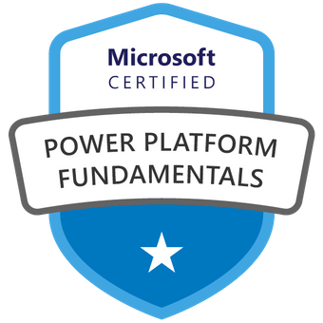

Education

Narula Institute of Technology (M.A.K.A.U.T.), Kolkata, West Bengal, India, Bachelor of Technology/**Electronics and Communication Engineering,** 2021

Professional Organizations

Capgemini, India

Publications/Presentations